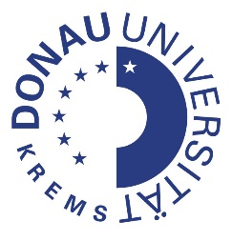

Program

2nd Krems Dementia Conference VIRTUAL

Dealing with Dementia: Prevention, Timely Detection and Awareness

Coordinated Efforts in Europe Between East and West

16-18 November 2020
Krems, Austria

Danube University Krems
Department for Clinical Neurosciences and Preventive Medicine
Center for Dementia Studies
Dr. Karl Dorrek Straße 30
3500 Krems / Austria
Sponsored by:

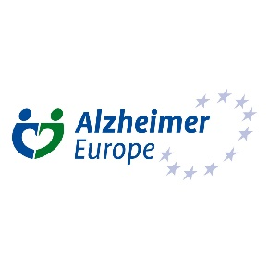

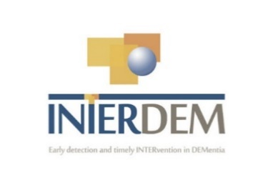

Cooperation Partners:
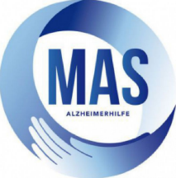

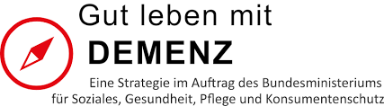
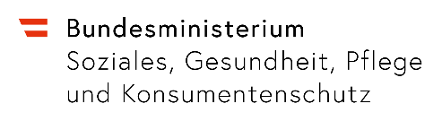

Dear Colleagues and Friends,

The Second Krems Dementia Conference goes virtual in 2020!
We are very happy to present a very interesting program again with many outstanding presentations.
The theme of the conference is Prevention, Timely detection and Awareness of dementia. Coordinated efforts between East and West. We will bring together persons with dementia, representatives of Alzheimer Associations, great researchers and policy makers to work on meaningful preventive strategies, bringing timely diagnostic and counselling services to persons with dementia and their families and motivate society to support these families and encourage them to stay in touch with life. We will also discuss the consequences of COVID-19 for people with dementia and their families and the first lessons that can be learned.

We are looking forward to meeting you online!

On behalf of the organizing committee,

Stefanie Auer, Marc Wortmann

MONDAY 16th NOVEMBER 2020

13:00-13:45 | Opening Ceremony  Stefanie Auer & Marc Wortmann  Stefan Nehrer (Dean, Danube-University-Krems)  Johanna Mikl-Leitner (Governor of Lower-Austria)
13:45-14:00 | Statement of a care giver representative  A plea on behalf of caregivers  Felicitas Maurer, Selbsthilfe Krems, Austria
14:00-14:15 | Expert-by-experience-statement  Helga Rohra, Dementia Activist, Germany
14:15-15:00 | Keynote: Social Health and Dementia Prevention  Myrra Vernooij Dassen, Radboud University Medical Center in Nijmegen, The Netherlands
15:00-15:45 | Keynote: The NYU Caregiver Program: years of experience  Mary Mittelman, NYU School of Medicine, USA

TUESDAY NOVEMBER 17th 2020
09:30- 10:45  09:30-09:45  09:45-10:00  10:00-10:15  10:15-10:30  10:30-10:45 | Community Projects (Part 1): How can integration be made possible?  The Dementia-friendly library Wiener Neustadt” – Health promotion for and with people with dementia and their careers in non-health settings  Verena Tatzer et al., University of Applied Sciences Wiener Neustadt, Austria  Dementia friendly police - an update  Markus Richter et al., BMI, Austria  Dementia Active Community  Gerhard Lang et al., BMI, Austria  The Dementia Network Upper Austria  Andreas Eckschlager, ÖGK, Austria  Why social care matters. The economics of dementia care in Austria  Alexander Braun et al., Institute for Health Care Management, University of Applied Sciences Krems, Austria
10:45-11:00 | Break
11:00-12:15  11:00-11:45  11:45-12:00  12:00-12:15 | Diagnostics  Keynote: The ABIDE project (translate knowledge from diagnostic tests into practice)  Wiesje van der Flier, Alzheimer Centre, Amsterdam, Netherlands  Cognitive Assessment for immigrants  Stefan Strotzka, Geronto-Psychiatric Center for Psychosocial Services, Vienna, Austria  How can we examine the patients with Subjective Cognitive Decline?  Magda Tsolaki, Ioulietta Lazarou, Department of Neurology, G.H. “AHEPA”, School of Medicine, Faculty of Health Sciences, Aristotle University of Thessaloniki, Greece
12:15-13:00 | Keynote: The World Stroke Organisation Proclamation of Prevention of Stroke and Dementia.  Michael Brainin, Department Clinical Neurosciences and Preventive Medicine, Danube University Krems, Austria
13:00-13:30 | Lunch Break
13:30-15:00  13:30-13:45  13:45-14:00  14:00-14:15  14:15-14:30  14:30-14:45  14:45-15:00 | Community Projects (Part 2): How can integration be made possible?  Alzheimer Cafés in Hungary - Response to the COVID-19 pandemic  Csaba Kucsera, Anna Holpert Eötvös Loránd University, Faculty of Social Sciences/Hungary  The MAKS® therapy: effects of a multimodal, non-pharmacological intervention for people with mild to moderate dementia  Elmar Grässel, Center for Health Services Research in Medicine, Department of Psychiatry and Psychotherapy, University Hospital Erlangen, Germany  Evaluating a complex intervention in integrated dementia care: a mixed methods research and design approach  Andrea Schmidt et al., National Public Health Institute, Austria  Perception of professional carers on quality of care of home dwelling people  Vladimira Dostalova, Charles University, Faculty of Humanities, Czech Republic  Digital Storytelling in Dementia Care  Christina Plößnig, Hilda Tellioğlu Technical University Vienna, Austria  AAL-technologies for/with people with dementia – the users perspective  Elisabeth Reitinger et al., University of Vienna, Austria
15:00-15:15 | Break
15:15-16:00 | Keynote: Rural primary care memory clinics in Saskatchewan.  Debra Morgan, University of Saskatchewan, Canada
16:00-16:45 | Keynote: How Prepared Are European Health Care Systems to Deliver a Future Alzheimer's Treatment?  Sören Mattke, University of Southern California

Parallel Workshop November 17th 2020
9:30-17:00 | AIDEM 2020  First International Symposium on Artificial Intelligence for  Dementia Prevention, Intervention and Care  Program  09:30 Welcome Note Lucas Paletta, Sandra Schüssler  09:40 Keynote 1: mHealth for Neuro Degenerative Diseases: Something to Remember Björn Schuller Imperial College London & University of Augsburg, Chair of Embedded Intelligence for Health Care and Wellbeing, CEO of audEERING GmbH Chair: Lucas Paletta  10:25 AI for Dementia Diagnosis: Imaging, Generalizability and Open Science Esther Bron Erasmus MC, Rotterdam, The Netherlands  10:50 Brain Changes Induced by a VR-based Mindfulness Training Guilherme Wood, Silvia Kober University of Graz, Graz, Austria  11:15 Keynote 2: Assistive Technology for Home-Dwelling People with Dementia in Times of COVID-19 Bettina Husebo University of Bergen, Department of Global Public Health and Primary Care (IGS), Centre for Elderly and Nursing Home Medicine (SEFAS) Chair: Sandra Schüssler  12:00 Break  13:00 Body and Brain Training with Big Data & AI for Seniors with Dementia Henrik Hautop Lund Technical University of Denmark, Lyngby, Denmark  13:25 Integrating Artificial Intelligence in a Web-based Interactive Educational Tool to Support People with Dementia and their Caregivers: An Explorative Feasibility Study Connor Buffel, Geert Vander Stichele Mindbytes, Edmonton, Canada  13:50 Multimodal Activation for Cognitive Performance in Dementia Care: Towards AI-enabled Decision Support Lucas Paletta, Silvia Russegger, Maria Fellner Joanneum Research, Graz, Austria digitAAL Life GmbH, Graz, Austria  14:15 Keynote 3: Dementia, Diversity, and Disparities: A Perspective from the United States Jennifer Schlesinger Associate Vice President, Healthcare Services and Community Education, Alzheimer's Los Angeles Chair: Lucas Paletta  15:00 Demo Session, Introduction Lucas Paletta, Maria Fellner  15:05 Demo #1: Playful Multimodal Activation with the digitAAL Life App Maria Fellner, digitAAL Life GmbH, Austria  Demo #2: SERES - Web-based Interactive Educational Tool for Family Caregivers of People with Dementia  Connor Buffel, Mindbytes, Canada  Demo #3: MIRA – A Gaze-based Serious Game for the Estimation of Alzheimer’s Mental State  Lucas Paletta, Joanneum Research, Austria  Demo #4: The Social Robot AMIGO: Coach and Companion for Persons with Dementia  Lucas Paletta, Joanneum Research, Austria  Demo #5: Augmented Reality Assistance Technologies in the Context of Care Services for People with Dementia in the Home Environment  Lucas Paletta, Joanneum Research, Austria  16:00 Goodbye note & end of Symposium Lucas Paletta

WEDNESDAY NOVEMBER 18th 2020
09:15- 11:15  09:15- 10:00  10:00- 10:15  10:15-10:30  10:30-11:15 | What did we learn from COVID-19?  Keynote: Challenging behaviour of nursing home residents during COVID-19 measures in The Netherlands  Debby Gerritsen, Radboud University, The Netherlands  People with dementia and Covid 19 pandemic- actual Croatian condition  Ninoslav Mimica, University Psychiatric Hospital Vrapče, Zagreb, Croatia  COVID-19 and Dementia - exchange of experiences and chances for the future  Alice Edtmayer, GOEG Austria  Keynote: Dementia and long-term care in COVID-19 times  Iva Holmerová, Charles University, Prague, Czech Republic
11:15-11:30 | Short break
11:30-12:30  11:30-11:40  11:40-11:50  11:50-12:00  12:00-12:10  12:10-12:30 | Update on dementia plans from different countries  Brigitte Juraszovic, GOEG Austria  Magda Tsolaki, Department of Neurology, G.H. “AHEPA”, School of Medicine, Faculty of Health Sciences, Aristotle University of Thessaloniki, Greece  Osman Kučuk, Emina Kučuk, Center for Dementia Sarajewo, Bosnia  Julia Riesch, Deutsches Zentrum für Altersfragen Geschäftsstelle Nationale Demenzstrategie, Germany  Discussion
12:30-13:00 | Lunch break
13:00-14:30 | Parallel Workshop : sponsored by Biogen : separate Registration necessary
13:00-13:15  13:15-13:30  13:30-13:45  13:45-14:00  14:00-14:15  14:15-14:30  14:30-14:45 | Awareness building and common projects  Interprofessional educational intervention in the Danube Region  Lea Pfäffel, Alexander Kurz, Technical University of Munich - School of Medicine, Germany  The Bike Memories service  Fragkiskos Spanos, Konstantina Anagnostopoulou, Kosmas Etolos, Greece  The voices of people with dementia and their carers: A strategy for public participation and involvement in a multinational psychosocial intervention trial  M. Geretsegger et al., The Grieg Academy Music Therapy Research Centre, NORCE Norwegian Research Centre, Bergen, Norway  DEMEDARTS Dementia.Empathy.Education.Arts  Ruth Mateus-Berr et al., University of applied Arts, Vienna, Austria  Learnings on dementia friendly-communities based on experiences in two networks “Gut leben mit Demenz in Klosterneuburg” (Lower Austria) and “MITEINANDER im demenzfreundlichen Hietzing” (Vienna)  Petra Mühlberger et al., Caritas Vienna, Austria  The dementia’s notebook  Konstantina Anagnostopoulou, Kosmas Etolos, Greece  Discussion
14:45-15:00 | Closing Session

Posters
(Available throughout the conference days via the website)

Johannes Lehrner: Screening for Dementia with the Vienna Visuo-Constructional Test 3.0 Screening (VVT 3.0 Screening)

Sinisa Stefanac: Utilization of occupational therapy services and relation to survival people taking dementia specific medication in Austria – a retrospective population based study with a 13 year old observation period

Albert Weinrauch: ICOS – a new method for early dementia detection

Rizwan Nadim, Martin Partridge, & Ruoling Chen: Caregivers perception on association between oral health and dementia: A focus group study

Anil Pokharel, Ashma Devkota, & Supriya Sharma: Basic Needs Management in Time of COVID Crisis in Local Level

Announcement:

3rd Krems Dementia Conference
28.-30. October 2021 Krems, Austria

Danube University Krems
Department for Clinical Neurosciences and Preventive Medicine
Center for Dementia Studies
Dr. Karl Dorrek Straße 30
3500 Krems / Austria

time table in CET

